**Assignment 03**

1. **Write a query to get unique department ID from employee table.**

**Ans :** Select Distinct department_Id From employees;

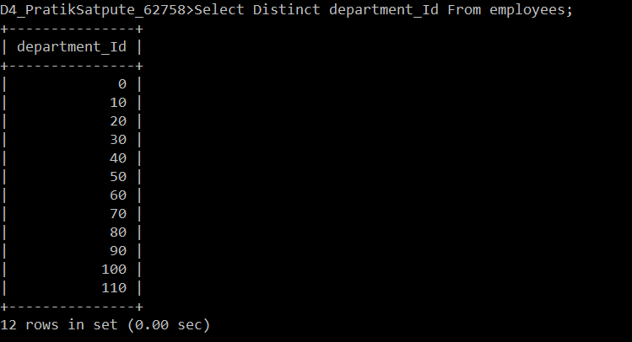

1. **Write a query to get all employee details from the employee table order by first name, descending**

**Ans :** select * from employees order by first_name desc ;

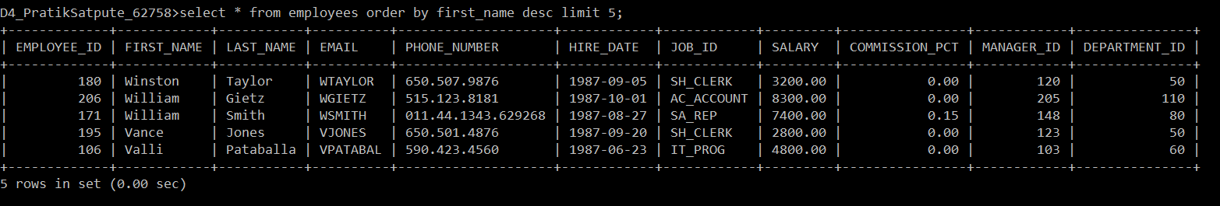

1. **Write a query to get the employee ID, names (first_name, last_name), salary in ascending order of salary**

**Ans :** Select employee_id , first_name, last_name, salary from employees order by salary;

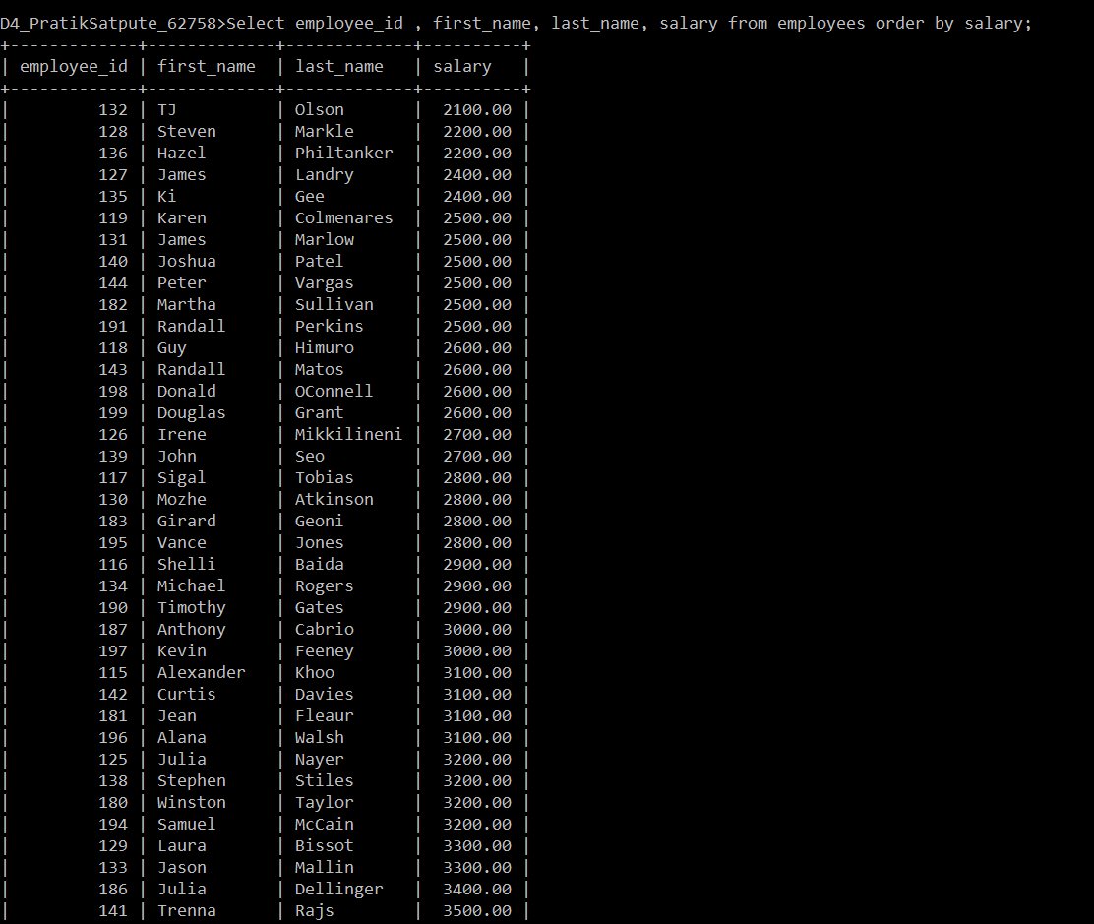

1. **Display first name and join date of the employees who is either IT Programmer or Sales Man.**

**Ans :** Select first_name, hire_date from employees where job_id = 'IT_prog ' OR job_id = 'SA_rep ';

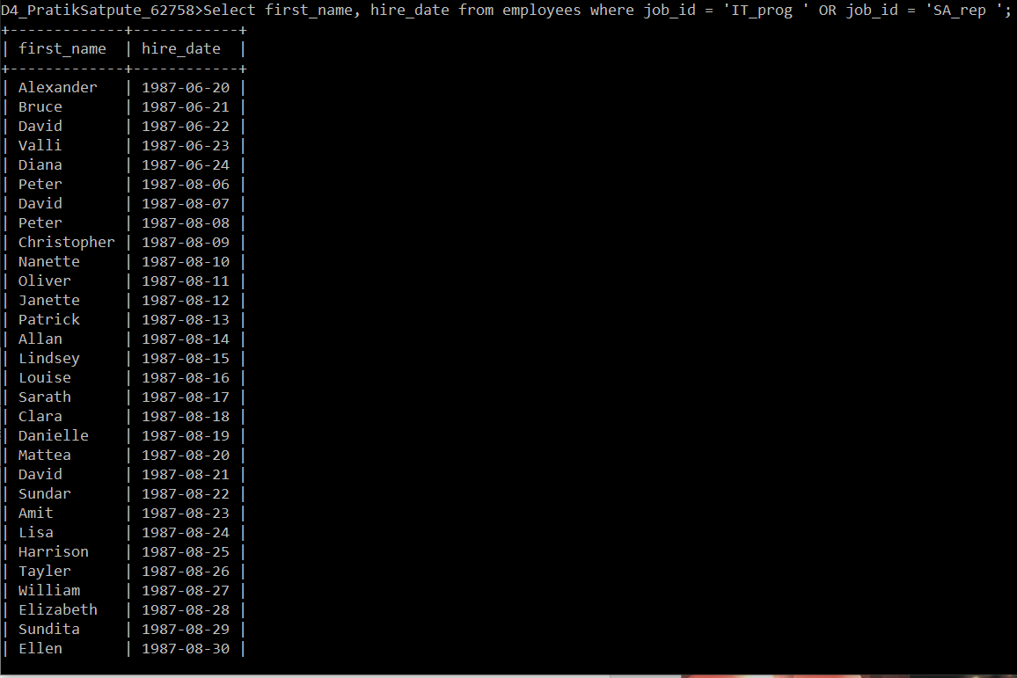

1. **Display details of employee with ID 150 or 160.**

**Ans**.

Select * from employees where employee_id = 150 or employee_id =160;

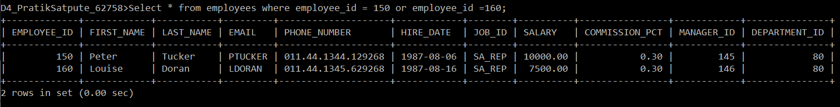

Select * from employees where employee_id IN(150 ,160);

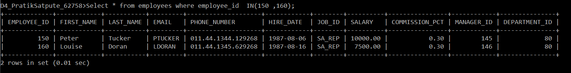

1. **Display first name, salary, commission pct, and hire date for employees with salary less than 10000.**

**Ans:**

select First_name, salary, commission_pct, hire_date from employees where salary <10000;

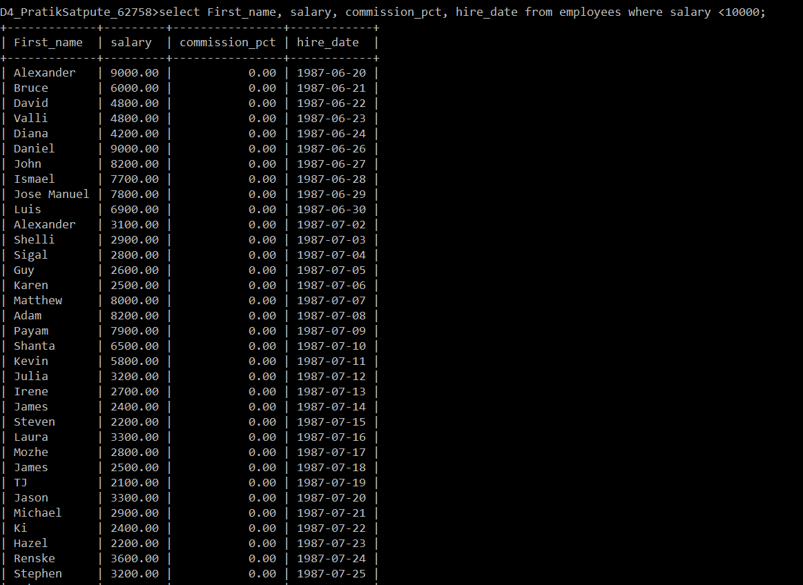

1. **Display employees where the first name or last name starts with S.**

**Ans :**

select * from employees where first_name like 'S%' OR Last_name like 'S%' ;

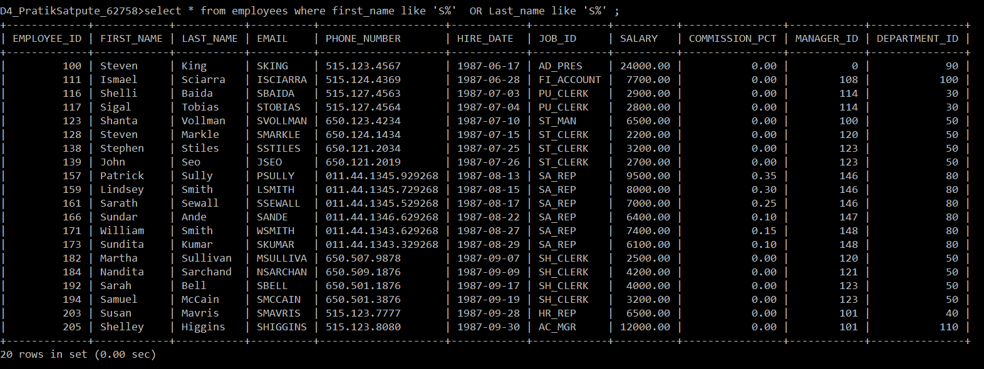

1. **Display details of jobs in the descending order of the title.**

**Ans :**

select * from employees order by job_id desc;

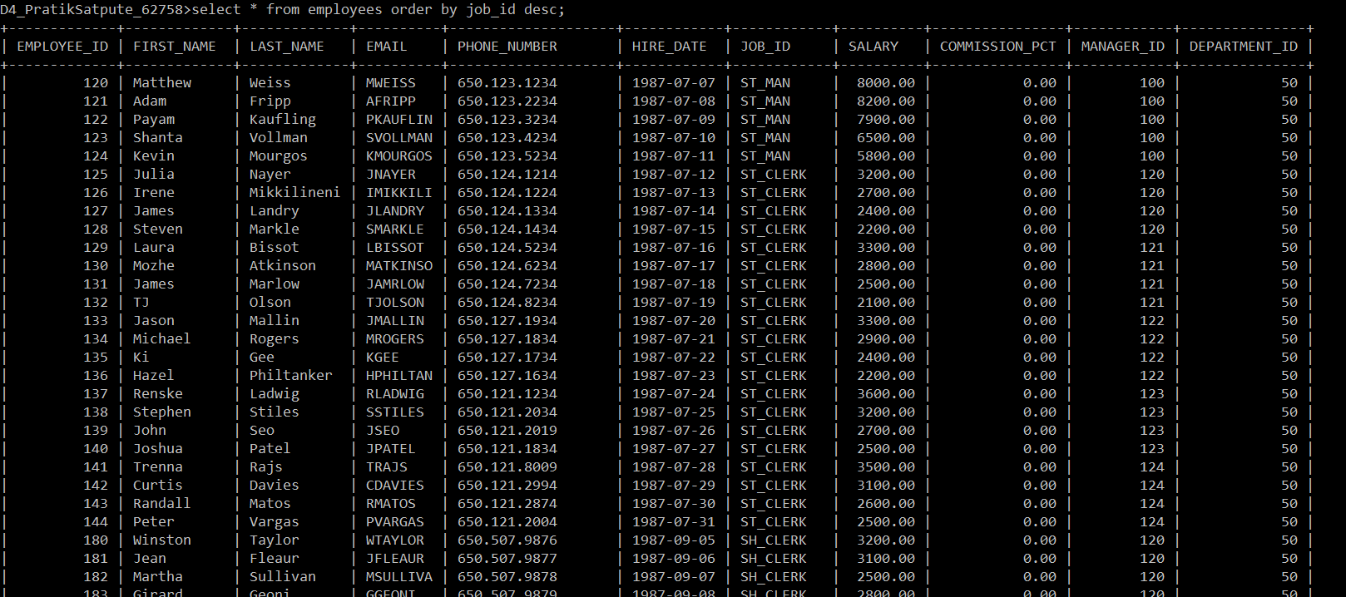

1. **Display details of the employees where commission percentage is null and salary in the range 5000 to 10000 and department is 30.**

**Ans:** select * from employees where commission_pct= null AND department_id = 30 AND salary between 5000 And 10000;



1. **Display employees first_name,email who are working in “Executive” department.**

**Ans.** Select first_name,email from employees where department_id = 90;

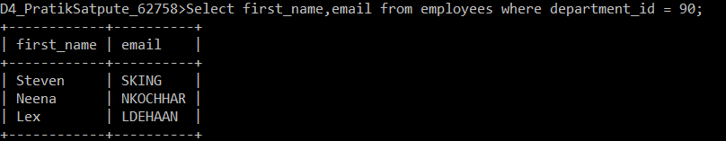

1. **Display unique contry_id from locations table.**

**Ans :** select country_id from locations;

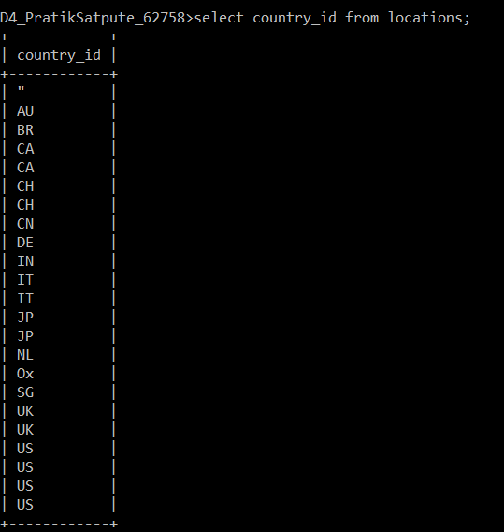

1. **Display all employees whose have job_id IT_PROG and FI_ACCOUNT.**

**Ans:** select * from employees where job_id in ('IT_PROG' , 'FI_ACCOUNT');

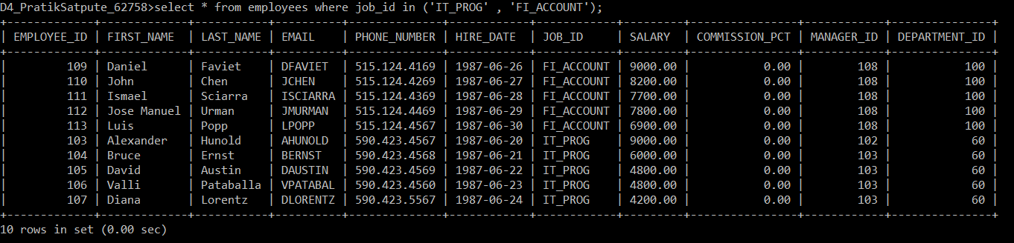

13**. Display all countries in ascending order.**

**Ans :**  select * from countries order by country_name;

